UNITED STATES
SECURITIES AND EXCHANGE COMMISSION
WASHINGTON, D.C. 20549

FORM 8-K

CURRENT REPORT
Pursuant to Section 13 or 15(d)
of the Securities Exchange Act of 1934
Date of report (Date of earliest event reported): August 3, 2026

ALLISON TRANSMISSION HOLDINGS, INC.
(Exact Name of Registrant as Specified in its Charter)

Delaware |  | 001-35456 |  | 26-0414014
(State or other jurisdiction  of incorporation) |  | (Commission  File Number) |  | (IRS Employer  Identification No.)
One Allison Way, Indianapolis, Indiana |  |  |  | 46222
(Address of principal executive offices) |  |  |  | (Zip Code)
Registrant’s telephone number, including area code: (317) 242-5000
Not Applicable
(Former name or former address, if changed since last report)

Check the appropriate box below if the Form 8-K filing is intended to simultaneously satisfy the filing obligation of the registrant under any of the following provisions (see General Instructions A.2. below):

☐ | Written communications pursuant to Rule 425 under the Securities Act (17 CFR 230.425)

☐ | Soliciting material pursuant to Rule 14a-12 under the Exchange Act (17 CFR 240.14a-12)

☐ | Pre-commencement communications pursuant to Rule 14d-2(b) under the Exchange Act (17 CFR 240.14d-2(b))

☐ | Pre-commencement communications pursuant to Rule 13e-4(c) under the Exchange Act (17 CFR 240.13e-4(c))
Securities registered pursuant to Section 12(b) of the Act:

Title of each class |  | Trading  Symbol(s) |  | Name of each exchange  on which registered
Common Stock, $0.01 par value |  | ALSN |  | New York Stock Exchange
Indicate by check mark whether the registrant is an emerging growth company as defined in Rule 405 of the Securities Act of 1933 (§ 230.405 of this chapter) or Rule 12b-2 of the Securities Exchange Act of 1934 (§ 240.12b-2 of this chapter).
Emerging growth company ☐
If an emerging growth company, indicate by check mark if the registrant has elected not to use the extended transition period for complying with any new or revised financial accounting standards provided pursuant to Section 13(a) of the Exchange Act. ☐

Item 2.02 | Results of Operations and Financial Condition.
On August 3, 2026, Allison Transmission Holdings, Inc. (“Allison”) published an earnings release reporting its financial results for the three months ended June 30, 2026. A copy of the earnings release is attached as Exhibit 99.1 hereto. Following the publication of the earnings release, Allison will host an earnings call on August 3, 2026 at 5:00 p.m. ET on which its financial results for the three months ended June 30, 2026 will be discussed. The investor presentation materials that will be used for the call are attached as Exhibit 99.2 hereto.
On August 3, 2026, Allison posted the materials attached as Exhibits 99.1 and 99.2 on its website (www.allisontransmission.com).
As discussed on page 2 of Exhibit 99.2, the investor presentation contains forward-looking statements within the meaning of the federal securities laws. These statements are present expectations and are subject to the limitations listed therein and in Allison’s other Securities and Exchange Commission filings, including that actual events or results may differ materially from those in the forward-looking statements.
The foregoing information (including the exhibits hereto) is being furnished and shall not be deemed “filed” for purposes of Section 18 of the Securities Exchange Act of 1934, as amended, or otherwise subject to the liabilities of that section, nor shall it be deemed incorporated by reference in any filing under the Securities Act of 1933, as amended, except as expressly set forth by specific reference in such filing.

Item 9.01 | Financial Statements and Exhibits.

(d) | Exhibits:

Exhibit  Number |  | Description
99.1 |  | Earnings release dated August 3, 2026.
99.2 |  | Investor presentation materials dated August 3, 2026.
104 |  | Cover Page Interactive Data File (embedded within the Inline XBRL document).

SIGNATURES
Pursuant to the requirements of the Securities Exchange Act of 1934, the registrant has duly caused this report to be signed on its behalf by the undersigned hereunto duly authorized.

 |  |  |  | Allison Transmission Holdings, Inc.
Date: August 3, 2026 |  |  |  | By: |  | /s/ Eric C. Scroggins
 |  |  |  | Name: |  | Eric C. Scroggins
 |  |  |  | Title: |  | Chief Legal Officer and Assistant Secretary
Exhibit 99.1

 |  | 
Allison Announces Second Quarter 2026 Results

* | Net Sales of $1,566 million, up 92% year over year, including the addition of the Allison Off-Highway business unit acquired on January 1, 2026

* | Record quarterly net sales of $860 million for the Allison Transmission business unit

* | Net Income of $181 million, 12% of Net Sales

* | Diluted EPS of $2.15, Adjusted Diluted EPS of $2.73, up 8% year over year

* | Adjusted EBITDA of $404 million, 26% of Net Sales, up 29% year over year
INDIANAPOLIS, August 3, 2026 – Allison Transmission Holdings Inc. (NYSE: ALSN), today reported second quarter net sales of $1,566 million with an adjusted EBITDA margin of 26 percent and net cash provided by operating activities of $312 million.
David S. Graziosi, Chair, President and Chief Executive Officer of Allison commented, “In the Allison Transmission business unit, execution of our growth initiatives in the Defense end market and continued momentum in the North American truck market led to record quarterly net sales of $860 million for the second quarter. We also saw strong year over year growth in the Allison Off-Highway business unit, particularly in the Construction & Material Handling and Mining end markets as demand continues to rebound from trough levels. The Agriculture end market, although showing signs of recovery in certain segments and regions, has yet to inflect positively.”
Graziosi continued, “The successful integration of the Allison Off-Highway business unit, including capturing planned synergies and realizing the strategic benefits of the combined operations, remains a top priority. At the same time, Allison continues to execute across both business units, converting improving demand conditions into strong cash generation, reflected in record quarterly adjusted free cash flow of $281 million in the second quarter. Alongside repurchasing $46 million of our common stock and paying a quarterly dividend, we also made additional progress toward our leverage target by repaying the remaining $150 million outstanding under our revolving credit facility.”
Second quarter results include segment reporting for Allison Transmission, the Company’s legacy business, excluding certain costs now accounted for within the Allison Central Group, and Allison Off-Highway, the business acquired from Dana Incorporated on January 1, 2026. The Allison Central Group is a centralized cost center which includes certain functional costs that support the Company’s global operations.
Allison Consolidated Second Quarter Financial Results
Net sales for the quarter were $1,566 million, including the addition of $706 million in net sales for the Allison Off-Highway business unit.
Gross profit for the quarter was $515 million, an increase of $112 million from $403 million for the same period in 2025. The increase was principally driven by the addition of the Allison Off-Highway business unit. Gross margin for the quarter was 33 percent.
Selling, general and administrative expenses for the quarter were $168 million, an increase of $64 million from $104 million for the same period in 2025. The increase was principally driven by the addition of the Allison Off-Highway business unit. Selling general and administrative expenses for the second quarter include $9 million of one-time acquisition-related expenses.
Engineering – research and development expenses for the quarter were $56 million, an increase of $13 million from $43 million for the same period in 2025. The increase was principally driven by the addition of the Allison Off-Highway business unit, partially offset by reduced product initiatives spending in the Allison Transmission business unit.

1

Net income for the quarter was $181 million, a decrease of $14 million from $195 million for the same period in 2025. The decrease was principally driven by increased operating costs due to the acquisition of the Allison Off-Highway business unit, including increased depreciation and amortization expense. The year over year decrease in net income was also driven by higher interest expense, net, and unrealized mark-to-market adjustments for marketable securities. The decrease in net income was partially offset by increased gross profit driven by the addition of the Allison Off-Highway business unit. Diluted EPS for the second quarter was $2.15, a year over year decrease of 6 percent.
Excluding the effect of certain non-cash, non-recurring, infrequent or unusual items, including the costs associated with the acquisition of the Allison Off-Highway business unit, adjusted net income, a non-GAAP financial measure, was $229 million for the second quarter and adjusted diluted EPS was $2.73, a year over year increase of 8 percent.
Adjusted EBITDA, a non-GAAP financial measure, was $404 million for the second quarter, an increase of $91 million from $313 million for the same period in 2025. Adjusted EBITDA margin for the quarter was 26 percent.
Net cash provided by operating activities for the quarter was $312 million, a year over year increase of 70 percent. Adjusted free cash flow, a non-GAAP financial measure, for the quarter was $281 million, a year over year increase of 84 percent.
Allison ended the second quarter with nearly $400 million of cash and cash equivalents and $995 million of available borrowing capacity under its revolving credit facility. Allison ended the second quarter with total debt of $4,114 million and net debt of $3,715 million.
During the second quarter, Allison paid a quarterly dividend of $0.29 per share and repurchased $46 million of its common stock, with $1,125 million of authorization remaining under its stock repurchase program.
Allison Transmission Second Quarter Financial Highlights
Net sales for the quarter increased 6 percent from the same period in 2025, leading to record quarterly net sales of $860 million.
Gross profit for the quarter was $397 million, a decrease of $6 million from $403 million for the same period in 2025. The decrease was principally driven by unfavorable direct material costs and higher manufacturing expense, partially offset by price increases on certain products. Gross margin for the second quarter was 46 percent.
Selling, general and administrative expenses for the quarter were $75 million, an increase of $3 million from $72 million for the same period in 2025 when adjusting for allocations of certain selling, general and administrative expenses to the Allison Central Group. The increase was principally driven by increased commercial activities spending.
Engineering – research and development expenses for the quarter were $41 million, a decrease of $2 million from $43 million for the same period in 2025. The decrease was principally driven by reduced product initiatives spending.
Segment operating profit was $281 million, or 33 percent of net sales, for the second quarter. Adjusted EBITDA, a non-GAAP financial measure, was $318 million for the second quarter. Adjusted EBITDA margin for the quarter was 37 percent.
Allison Off-Highway Second Quarter Financial Highlights
Net sales for the quarter were $706 million.
Gross profit for the quarter was $118 million, representing 17 percent of net sales.
Selling, general and administrative expenses for the quarter were $56 million. Engineering – research and development expenses for the quarter were $15 million.
Segment operating profit was $47 million, or 7 percent of net sales, for the second quarter. Adjusted EBITDA, a non-GAAP financial measure, was $104 million for the second quarter. Adjusted EBITDA margin for the quarter was 15 percent.

2

Full Year 2026 Guidance Update
Given our second quarter results and improving conditions across our end markets, we are increasing our full year 2026 guidance provided to the market on May 4, 2026. Allison expects:

 |  |  | Consolidated net sales in the range of $5,800 to $6,000 million

 |  |  | Consolidated net income in the range of $600 to $700 million, subject to the completion of purchase price accounting associated with the acquisition of the Allison Off-Highway business unit

 |  |  | Net income guidance includes approximately $140 million of one-time, pre-tax expenses associated with the separation, integration and restructuring of the Allison Off-Highway business unit, including approximately $75 million of expenses related to the stepped-up basis in inventory. Net income guidance also includes $50 million of additional depreciation. Including one-time costs, the Allison Off-Highway acquisition is expected to be accretive to net income and diluted EPS in 2026

 |  |  | Consolidated adjusted EBITDA in the range of $1,465 to $1,575 million

 |  |  | Consolidated net cash provided by operating activities in the range of $1,025 to $1,125 million, including approximately $55 million of one-time cash outlays associated with the acquisition of the Allison Off-Highway business unit

 |  |  | Consolidated capital expenditures in the range of $260 to $280 million, including one-time separation and integration capital expenditures of approximately $30 million

 |  |  | Consolidated adjusted free cash flow in the range of $745 to $865 million

3

Conference Call and Webcast
The Company will host a conference call at 5:00 p.m. EDT on Monday, August 3, 2026 to discuss its second quarter 2026 results. The dial-in phone number for the conference call is +1-877-425-9470 and the international dial-in number is +1-201-389-0878. A live webcast of the conference call will also be available online at https://ir.allisontransmission.com.
For those unable to participate in the conference call, a replay will be available from 9:00 p.m. EDT on August 3 until 11:59 p.m. EDT on August 17. The replay dial-in phone number is +1-844-512-2921 and the international replay dial-in number is +1-412-317-6671. The replay passcode is 13761420.
About Allison
Allison (NYSE: ALSN) is a global leader in high-performance mobility and work solutions built for the needs of the modern industrial world. Allison operates through two business units: Allison Transmission and Allison Off-Highway Drive & Motion Systems. Headquartered in Indianapolis, Indiana, USA, the Company manufactures solutions which offer industry-leading value propositions across vital sectors such as infrastructure, mining, energy, agriculture, construction, transportation and national security. For over 110 years, Allison has been recognized as a reliable partner of choice, keeping essential industries moving anytime, in over 150 countries around the world. For more information, visit https://allisontransmission.com.
Forward-Looking Statements
This press release contains forward-looking statements. The words “believe,” “expect,” “anticipate,” “intend,” “estimate” and other expressions that are predictions of or indicate future events and trends and that do not relate to historical matters identify forward-looking statements. You should not place undue reliance on these forward-looking statements. Although forward-looking statements reflect management’s good faith beliefs, reliance should not be placed on forward-looking statements because they involve known and unknown risks, uncertainties and other factors, which may cause actual results, performance or achievements to differ materially from anticipated future results, performance or achievements expressed or implied by such forward-looking statements. Forward-looking statements speak only as of the date the statements are made. We undertake no obligation to publicly update or revise any forward-looking statement, whether as a result of new information, future events, changed circumstances or otherwise. These forward-looking statements are subject to numerous risks and uncertainties, including, but not limited to: the significant costs we are expected to incur in connection with the integration of the Off-Highway Drive & Motion Systems business of Dana Incorporated (now referred to as the “Allison Off-Highway Business”); our ability to successfully integrate the Allison Off-Highway Business and its operations in the expected time frame; our ability to realize all of the anticipated benefits from the integration of the Allison Off-Highway Business and its operations and to effectively manage our expanded operations; our participation in markets that are competitive; our ability to prepare for, respond to and successfully achieve our objectives relating to technological and market developments, competitive threats and changing customer needs, including with respect to electric hybrid and fully electric commercial vehicles; increases in cost, disruption of supply or shortage of labor, freight, raw materials, energy or components used to manufacture or transport our products or those of our customers or suppliers, including as a result of geopolitical risks, natural disasters, extreme weather events, wars and public health crises such as pandemics; global economic volatility; general economic and industry conditions, including the risk of prolonged inflation and recession; labor strikes, work stoppages or similar labor disputes, which could significantly disrupt our operations or those of our principal customers or suppliers; the highly cyclical industries in which certain of our end users operate; uncertainty in the global regulatory and business environments in which we operate; the concentration of our net sales in our top five customers and the loss of any one of these customers; cybersecurity risks to our operational systems, security systems or infrastructure owned by us or our third-party vendors and suppliers; the failure of markets outside North America to increase adoption of fully automatic transmissions; the success of our research and development efforts, the outcome of which is uncertain; U.S. and foreign defense spending; risks associated with our international operations, including acts of war and increased trade protectionism and tariffs; the discovery of defects in our products, resulting in delays in new model launches, recall campaigns and/or increased warranty costs and reduction in future sales or damage to our brand and reputation; our ability to identify, consummate and effectively integrate acquisitions and collaborations; and risks related to our indebtedness.

4

Use of Non-GAAP Financial Measures
This press release contains information about Allison’s financial results and forward-looking estimates of financial results that are not presented in accordance with accounting principles generally accepted in the United States (“GAAP”). Such non-GAAP financial measures are reconciled to their most directly comparable GAAP financial measures at the end of this press release. Non-GAAP financial measures should not be considered in isolation or as a substitute for our reported results prepared in accordance with GAAP and, as calculated, may not be comparable to other similarly titled measures of other companies.
We use adjusted earnings before interest, taxes, depreciation, and amortization (“EBITDA”) and adjusted EBITDA as a percent of net sales (“adjusted EBITDA margin”) to measure our operating profitability. We believe that adjusted EBITDA and adjusted EBITDA margin provide management, investors and creditors with useful measures of the operational results of our business and increase the period-to-period comparability of our operating profitability. Adjusted EBITDA margin is also used in the calculation of management’s incentive compensation program. The most directly comparable GAAP measure to adjusted EBITDA and adjusted EBITDA margin is net income or segment operating profit (loss) in the case of our segments and net income as a percent of net sales (“net income margin”) or segment operating profit (loss) as a percent of net sales in the case of our segments, respectively. Adjusted EBITDA is calculated as earnings before interest expense, net, income tax expense, amortization of intangible assets, depreciation of property, plant and equipment and other adjustments as defined by the Second Amended and Restated Credit Agreement dated as of March 29, 2019, as amended, governing Allison Transmission, Inc.’s term loans and revolving credit facility. Adjusted EBITDA margin is calculated as adjusted EBITDA divided by net sales.
In addition, we believe adjusted net income, adjusted basic earnings per share attributable to common stockholders (“adjusted basic EPS”) and adjusted diluted earnings per share attributable to common stockholders (“adjusted diluted EPS”) provide management, investors and creditors with useful measures of our core business performance and trends and increase the period-to-period comparability of our results of operations. The most directly comparable GAAP measure to adjusted net income, adjusted basic EPS and adjusted diluted EPS is net income, basic earnings per share attributable to common stockholders (“basic EPS”) and diluted earnings per share attributable to common stockholders (“diluted EPS”), respectively. Adjusted net income is calculated as net income excluding the effect of certain non-cash, non-recurring, infrequent or unusual items such as: amortization related to acquired intangible assets, depreciation of the stepped-up basis in property, plant and equipment related to acquired assets, stepped-up basis in acquired inventory, stock-based compensation expense, acquisition-related expenses, impairment charges, other one-off adjustments and the tax effect of the adjustments. Adjusted basic EPS is calculated by dividing adjusted net income by the weighted average shares of common stock outstanding and adjusted diluted EPS is calculated by dividing adjusted net income by the diluted weighted average shares of common stock outstanding.
We use adjusted free cash flow to evaluate the amount of cash generated by our business that, after the capital investment needed to maintain and grow our business and certain mandatory debt service requirements, can be used for repayment of debt, stockholder distributions and strategic opportunities, including investing in our business. We believe that adjusted free cash flow enhances the understanding of the cash flows of our business for management, investors and creditors. Adjusted free cash flow is also used in the calculation of management’s incentive compensation program. The most directly comparable GAAP measure to adjusted free cash flow is net cash provided by operating activities. Adjusted free cash flow is calculated as net cash provided by operating activities after cash used for additions of long-lived assets.
Attachments

 |  |  | Condensed Consolidated Statements of Operations

 |  |  | Condensed Consolidated Balance Sheets

 |  |  | Condensed Consolidated Statements of Cash Flows

 |  |  | Reconciliations of GAAP to Non-GAAP Financial Measures

 |  |  | Reconciliation of GAAP to Non-GAAP Financial Measures for Full Year Guidance
Contacts
Jackie Bolles
Executive Director, Treasury and Investor Relations
jacalyn.bolles@allisontransmission.com
(317) 242-7073
Media Relations
media@allisontransmission.com
(317) 694-2065

5

Allison Transmission Holdings, Inc.
Condensed Consolidated Statements of Operations
(Unaudited, dollars in millions, except per share data)

 |  | Allison Transmission |  |  |  |  |  |  |  | Allison Off-Highway |  |  |  |  |  |  |  | Central Group Funtion |  |  |  |  |  |  |  | Consolidated
 |  | Three months ended  June 30, |  |  |  |  |  |  |  | Three months ended  June 30, |  |  |  |  |  |  |  | Three months ended  June 30, |  |  |  |  |  |  |  | Three months ended  June 30,
 |  | 2026 |  |  |  | 2025 |  |  |  | 2026 |  |  |  | 2025 |  |  |  | 2026 |  |  |  | 2025 |  |  |  | 2026 |  |  |  | 2025
Net sales |  | $ | 860 |  |  | $ | 814 |  |  | $ | 706 |  |  | $ | — |  |  | $ | — |  |  | $ | — |  |  | $ | 1,566 |  |  | $ | 814
Cost of sales |  |  | 463 |  |  |  | 411 |  |  |  | 588 |  |  |  | — |  |  |  | — |  |  |  | — |  |  |  | 1,051 |  |  |  | 411
Gross profit |  |  | 397 |  |  |  | 403 |  |  |  | 118 |  |  |  | — |  |  |  | — |  |  |  | — |  |  |  | 515 |  |  |  | 403
Selling, general and administrative |  |  | 75 |  |  |  | 72 |  |  |  | 56 |  |  |  | — |  |  |  | 37 |  |  |  | 32 |  |  |  | 168 |  |  |  | 104
Engineering - research and development |  |  | 41 |  |  |  | 43 |  |  |  | 15 |  |  |  | — |  |  |  | — |  |  |  | — |  |  |  | 56 |  |  |  | 43
Operating income (loss) |  | $ | 281 |  |  | $ | 288 |  |  | $ | 47 |  |  | $ | — |  |  | $ | (37 | ) |  | $ | (32 | ) |  |  | 291 |  |  |  | 256
Interest expense, net |  |  |  |  |  |  |  |  |  |  |  |  |  |  |  |  |  |  |  |  |  |  |  |  |  |  | (54 | ) |  |  | (22 | )
Other (expense) income, net |  |  |  |  |  |  |  |  |  |  |  |  |  |  |  |  |  |  |  |  |  |  |  |  |  |  | (9 | ) |  |  | 8
Income before income taxes |  |  |  |  |  |  |  |  |  |  |  |  |  |  |  |  |  |  |  |  |  |  |  |  |  |  | 228 |  |  |  | 242
Income tax expense |  |  |  |  |  |  |  |  |  |  |  |  |  |  |  |  |  |  |  |  |  |  |  |  |  |  | (47 | ) |  |  | (47 | )
Net income |  |  |  |  |  |  |  |  |  |  |  |  |  |  |  |  |  |  |  |  |  |  |  |  |  | $ | 181 |  |  | $ | 195
Basic earnings per share attributable to common stockholders |  |  |  |  |  |  |  |  |  |  |  |  |  |  |  |  |  |  |  |  |  |  |  |  |  | $ | 2.18 |  |  | $ | 2.32
Diluted earnings per share attributable to common stockholders |  |  |  |  |  |  |  |  |  |  |  |  |  |  |  |  |  |  |  |  |  |  |  |  |  | $ | 2.15 |  |  | $ | 2.29
 |  | Allison Transmission |  |  |  |  |  |  |  | Allison Off-Highway |  |  |  |  |  |  |  | Central Group Funtion |  |  |  |  |  |  |  | Consolidated
 |  | Six months ended  June 30, |  |  |  |  |  |  |  | Six months ended  June 30, |  |  |  |  |  |  |  | Six months ended June 30, |  |  |  |  |  |  |  | Six months ended  June 30,
 |  | 2026 |  |  |  | 2025 |  |  |  | 2026 |  |  |  | 2025 |  |  |  | 2026 |  |  |  | 2025 |  |  |  | 2026 |  |  |  | 2025
Net sales |  | $ | 1,593 |  |  | $ | 1,580 |  |  | $ | 1,379 |  |  | $ | — |  |  | $ | — |  |  | $ | — |  |  | $ | 2,972 |  |  | $ | 1,580
Cost of sales |  |  | 840 |  |  |  | 799 |  |  |  | 1,211 |  |  |  | — |  |  |  | — |  |  |  | — |  |  |  | 2,051 |  |  |  | 799
Gross profit |  |  | 753 |  |  |  | 781 |  |  |  | 168 |  |  |  | — |  |  |  | — |  |  |  | — |  |  |  | 921 |  |  |  | 781
Selling, general and administrative |  |  | 140 |  |  |  | 137 |  |  |  | 112 |  |  |  | — |  |  |  | 73 |  |  |  | 54 |  |  |  | 325 |  |  |  | 191
Engineering - research and development |  |  | 80 |  |  |  | 85 |  |  |  | 30 |  |  |  | — |  |  |  | — |  |  |  | — |  |  |  | 110 |  |  |  | 85
Operating income (loss) |  | $ | 533 |  |  | $ | 559 |  |  | $ | 26 |  |  | $ | — |  |  | $ | (73 | ) |  | $ | (54 | ) |  |  | 486 |  |  |  | 505
Interest expense, net |  |  |  |  |  |  |  |  |  |  |  |  |  |  |  |  |  |  |  |  |  |  |  |  |  |  | (115 | ) |  |  | (43 | )
Other (expense) income, net |  |  |  |  |  |  |  |  |  |  |  |  |  |  |  |  |  |  |  |  |  |  |  |  |  |  | (11 | ) |  |  | 13
Income before income taxes |  |  |  |  |  |  |  |  |  |  |  |  |  |  |  |  |  |  |  |  |  |  |  |  |  |  | 360 |  |  |  | 475
Income tax expense |  |  |  |  |  |  |  |  |  |  |  |  |  |  |  |  |  |  |  |  |  |  |  |  |  |  | (67 | ) |  |  | (88 | )
Net income |  |  |  |  |  |  |  |  |  |  |  |  |  |  |  |  |  |  |  |  |  |  |  |  |  | $ | 293 |  |  | $ | 387
Basic earnings per share attributable to common stockholders |  |  |  |  |  |  |  |  |  |  |  |  |  |  |  |  |  |  |  |  |  |  |  |  |  | $ | 3.53 |  |  | $ | 4.55
Diluted earnings per share attributable to common stockholders |  |  |  |  |  |  |  |  |  |  |  |  |  |  |  |  |  |  |  |  |  |  |  |  |  | $ | 3.49 |  |  | $ | 4.50

6

Allison Transmission Holdings, Inc.
Condensed Consolidated Balance Sheets
(Unaudited, dollars in millions)

 |  | June 30,  2026 |  |  |  | December 31,  2025
ASSETS
Current Assets
Cash and cash equivalents |  | $ | 399 |  |  | $ | 1,495
Accounts receivable, net |  |  | 911 |  |  |  | 333
Inventories |  |  | 840 |  |  |  | 316
Other current assets |  |  | 239 |  |  |  | 89
Total Current Assets |  |  | 2,389 |  |  |  | 2,233
Property, plant and equipment, net |  |  | 1,660 |  |  |  | 862
Intangible assets, net |  |  | 1,607 |  |  |  | 794
Goodwill |  |  | 2,812 |  |  |  | 2,075
Other non-current assets |  |  | 249 |  |  |  | 118
TOTAL ASSETS |  | $ | 8,717 |  |  | $ | 6,082
LIABILITIES
Current Liabilities
Accounts payable |  | $ | 806 |  |  | $ | 190
Product warranty liability |  |  | 65 |  |  |  | 34
Current portion of long-term debt |  |  | 20 |  |  |  | 5
Deferred revenue |  |  | 73 |  |  |  | 34
Other current liabilities |  |  | 358 |  |  |  | 197
Total Current Liabilities |  |  | 1,322 |  |  |  | 460
Product warranty liability |  |  | 63 |  |  |  | 50
Deferred revenue |  |  | 105 |  |  |  | 103
Long-term debt |  |  | 4,094 |  |  |  | 2,885
Deferred income taxes |  |  | 839 |  |  |  | 557
Other non-current liabilities |  |  | 315 |  |  |  | 160
TOTAL LIABILITIES |  |  | 6,738 |  |  |  | 4,215
TOTAL STOCKHOLDERS’ EQUITY |  |  | 1,979 |  |  |  | 1,867
TOTAL LIABILITIES & STOCKHOLDERS’ EQUITY |  | $ | 8,717 |  |  | $ | 6,082

7

Allison Transmission Holdings, Inc.
Condensed Consolidated Statements of Cash Flows
(Unaudited, dollars in millions)

 |  | Three months ended  June 30, |  |  |  |  |  |  |  | Six months ended  June 30,
 |  | 2026 |  |  |  | 2025 |  |  |  | 2026 |  |  |  | 2025
Net cash provided by operating activities |  | $ | 312 |  |  | $ | 184 |  |  | $ | 468 |  |  | $ | 365
Net cash used for investing activities (a) (b) |  |  | — |  |  |  | (33 | ) |  |  | (2,616 | ) |  |  | (59 | )
Net cash (used for) provided by financing activities |  |  | (224 | ) |  |  | (132 | ) |  |  | 1,056 |  |  |  | (316 | )
Effect of exchange rate changes on cash |  |  | — |  |  |  | 6 |  |  |  | (4 | ) |  |  | 7
Net increase (decrease) in cash and cash equivalents |  |  | 88 |  |  |  | 25 |  |  |  | (1,096 | ) |  |  | (3 | )
Cash and cash equivalents at beginning of period |  |  | 311 |  |  |  | 753 |  |  |  | 1,495 |  |  |  | 781
Cash and cash equivalents at end of period |  | $ | 399 |  |  | $ | 778 |  |  | $ | 399 |  |  | $ | 778
Supplemental disclosures:
Interest paid |  | $ | (66 | ) |  | $ | (33 | ) |  | $ | (107 | ) |  | $ | (60 | )
Income taxes paid |  | $ | (84 | ) |  | $ | (93 | ) |  | $ | (95 | ) |  | $ | (95 | )
Interest received from interest rate swaps |  | $ | — |  |  | $ | 2 |  |  | $ | — |  |  | $ | 4
(a) Business acquisition, net of cash acquired |  | $ | 34 |  |  | $ | — |  |  | $ | (2,529 | ) |  |  | —
(b) Additions of long-lived assets |  | $ | (31 | ) |  | $ | (31 | ) |  | $ | (84 | ) |  | $ | (57 | )

8

Allison Transmission Holdings, Inc.
Reconciliation of GAAP to Non-GAAP Financial Measures
(Unaudited, dollars in millions)

 |  | Three months ended  June 30, |  |  |  |  |  |  |  | Six months ended  June 30,
 |  | 2026 |  |  |  | 2025 |  |  |  | 2026 |  |  |  | 2025
Net income (GAAP) plus: |  | $ | 181 |  |  | $ | 195 |  |  | $ | 293 |  |  | $ | 387
Interest expense, net |  |  | 54 |  |  |  | 22 |  |  |  | 115 |  |  |  | 43
Depreciation of property, plant and equipment |  |  | 46 |  |  |  | 29 |  |  |  | 90 |  |  |  | 57
Income tax expense |  |  | 47 |  |  |  | 47 |  |  |  | 67 |  |  |  | 88
Amortization expense |  |  | 21 |  |  |  | 1 |  |  |  | 44 |  |  |  | 3
Recognition of the stepped-up basis in inventory (a) |  |  | — |  |  |  | — |  |  |  | 63 |  |  |  | —
Depreciation of the stepped up basis in property, plant and equipment (b) |  |  | 18 |  |  |  | — |  |  |  | 31 |  |  |  | —
Acquisition-related expenses (c) |  |  | 9 |  |  |  | 15 |  |  |  | 26 |  |  |  | 24
Stock-based compensation expense (d) |  |  | 10 |  |  |  | 8 |  |  |  | 17 |  |  |  | 14
Unrealized loss (gain) on marketable securities (e) |  |  | 12 |  |  |  | (5 | ) |  |  | 9 |  |  |  | (8 | )
Unrealized loss on foreign exchange (f) |  |  | — |  |  |  | 1 |  |  |  | 3 |  |  |  | 1
Loss associated with impairment of long-lived assets (g) |  |  | 2 |  |  |  | — |  |  |  | 2 |  |  |  | —
Other (h) |  |  | 4 |  |  |  | — |  |  |  | 6 |  |  |  | —
Adjusted EBITDA (Non-GAAP) |  | $ | 404 |  |  | $ | 313 |  |  | $ | 766 |  |  | $ | 609
Net sales (GAAP) |  | $ | 1,566 |  |  | $ | 814 |  |  | $ | 2,972 |  |  | $ | 1,580
Net income as a percent of Net sales (GAAP) |  |  | 11.6 | % |  |  | 24.0 | % |  |  | 9.9 | % |  |  | 24.5 | %
Adjusted EBITDA as a percent of Net sales (Non-GAAP) |  |  | 25.8 | % |  |  | 38.5 | % |  |  | 25.8 | % |  |  | 38.5 | %
Net cash provided by operating activities (GAAP) |  | $ | 312 |  |  | $ | 184 |  |  | $ | 468 |  |  | $ | 365
Deductions to reconcile to Adjusted free cash flow:
Additions of long-lived assets |  |  | (31 | ) |  |  | (31 | ) |  |  | (84 | ) |  |  | (57 | )
Adjusted free cash flow (Non-GAAP) |  | $ | 281 |  |  | $ | 153 |  |  | $ | 384 |  |  | $ | 308

(a) | Represents the recognition of the stepped-up basis in inventory related to our acquisition of the Dana Off-Highw ay business (the “Acquisition”) (recorded in Cost of sales).
(b) | Represents depreciation of the stepped-up basis in property, plant and equipment related to the Acquisition (recorded in Cost of sales).
(c) | Represents expenses (recorded in Selling, general and administrative), primarily consulting and legal fees, related to the Acquisition.
(d) | Represents stock-based compensation expense (recorded in Selling, general and administrative).
(e) | Represents unrealized losses (gains) (recorded in Other (expense) income, net) related to an investment in the common stock of Jing-Jin Electric Technologies Co. Ltd.
(f) | Represents losses (recorded in Other (expense) income, net) on intercompany financing transactions for our facility in Chennai, India.
(g) | Represents a charge associated with the impairment of long-lived assets related to the production of certain electrified products.
(h) | Represents other adjustments as defined by the Second Amended and Restated Credit Agreement dated as of March 29, 2019 as amended.

9

Allison Transmission Holdings, Inc.
Reconciliation of GAAP to Non-GAAP Financial Measures
(Unaudited, dollars in millions)

 |  | Allison Transmission |  |  |  | Allison Off-Highway |  |  |  | Central Group Function |  |  |  | Consolidated
 |  | Three months ended  June 30, |  |  |  | Three months ended  June 30, |  |  |  | Three months ended  June 30, |  |  |  | Three months ended  June 30,
 |  | 2026 |  |  |  | 2026 |  |  |  | 2026 |  |  |  | 2026 |  |  |  | 2025
Segment Operating Profit/(Loss) (GAAP) |  | $ | 281 |  |  | $ | 47 |  |  | $ | (37 | ) |  | $ | 291 |  |  | $ | 256
plus:
Depreciation of property, plant and equipment |  |  | 31 |  |  |  | 15 |  |  |  | — |  |  |  | 46 |  |  |  | 29
Amortization expense |  |  | — |  |  |  | 21 |  |  |  | — |  |  |  | 21 |  |  |  | 1
Acquisition-related expenses (a) |  |  | — |  |  |  | — |  |  |  | 9 |  |  |  | 9 |  |  |  | 15
Depreciation of the stepped up basis in property, plant and equipment (b) |  |  | — |  |  |  | 18 |  |  |  | — |  |  |  | 18 |  |  |  | —
Stock-based compensation expense (c) |  |  | — |  |  |  | — |  |  |  | 10 |  |  |  | 10 |  |  |  | 8
Loss associated with the impairment of long-lived assets (d) |  |  | 2 |  |  |  | — |  |  |  | — |  |  |  | 2 |  |  |  | —
Other (e) |  |  | 4 |  |  |  | 3 |  |  |  | — |  |  |  | 7 |  |  |  | 4
Adjusted EBITDA (Non-GAAP) |  | $ | 318 |  |  | $ | 104 |  |  | $ | (18 | ) |  | $ | 404 |  |  | $ | 313
Net sales (GAAP) |  | $ | 860 |  |  | $ | 706 |  |  | $ | — |  |  | $ | 1,566 |  |  | $ | 814
Segment Operating Profit/(Loss) as a percent of Net sales (GAAP) |  |  | 32.7 | % |  |  | 6.7 | % |  |  | — |  |  |  | 18.6 | % |  |  | 31.4 | %
Adjusted EBITDA as a percent of Net sales (Non-GAAP) |  |  | 37.0 | % |  |  | 14.7 | % |  |  | — |  |  |  | 25.8 | % |  |  | 38.5 | %

(a) | Represents expenses (recorded in Selling, general and administrative), primarily consulting and legal fees, related to the Acquisition.
(b) | Represents depreciation of the stepped-up basis in property, plant and equipment related to the Acquisition (recorded in Cost of sales).
(c) | Represents stock-based compensation expense (recorded in Selling, general and administrative).
(d) | Represents a charge associated with the impairment of long-lived assets related to the production of certain electrified products.
(e) | Represents gains and losses (recorded in Other (expense) income, net) to reconcile to Adjusted EBITDA.

 |  | Allison Transmission |  |  |  | Allison Off-Highway |  |  |  | Central Group Function |  |  |  | Consolidated
 |  | Six months ended  June 30, |  |  |  | Six months ended  June 30, |  |  |  | Six months ended  June 30, |  |  |  | Six months ended  June 30,
 |  | 2026 |  |  |  | 2026 |  |  |  | 2026 |  |  |  | 2026 |  |  |  | 2025
Segment Operating Profit/(Loss) (GAAP) |  | $ | 533 |  |  | $ | 26 |  |  | $ | (73 | ) |  | $ | 486 |  |  | $ | 505
plus:
Depreciation of property, plant and equipment |  |  | 61 |  |  |  | 29 |  |  |  | — |  |  |  | 90 |  |  |  | 57
Amortization expense |  |  | 1 |  |  |  | 43 |  |  |  | — |  |  |  | 44 |  |  |  | 3
Recognition of the stepped-up basis in inventory (a) |  |  | — |  |  |  | 63 |  |  |  | — |  |  |  | 63 |  |  |  | —
Acquisition-related expenses (b) |  |  | — |  |  |  | — |  |  |  | 26 |  |  |  | 26 |  |  |  | 24
Depreciation of the stepped up basis in property, plant and equipment (c) |  |  | — |  |  |  | 31 |  |  |  | — |  |  |  | 31 |  |  |  | —
Stock-based compensation expense (d) |  |  | — |  |  |  | — |  |  |  | 17 |  |  |  | 17 |  |  |  | 14
Loss associated with the impairment of long-lived assets (e) |  |  | 2 |  |  |  | — |  |  |  | — |  |  |  | 2 |  |  |  | —
Other (f) |  |  | (3 | ) |  |  | 10 |  |  |  | — |  |  |  | 7 |  |  |  | 6
Adjusted EBITDA (Non-GAAP) |  | $ | 594 |  |  | $ | 202 |  |  | $ | (30 | ) |  | $ | 766 |  |  | $ | 609
Net sales (GAAP) |  | $ | 1,593 |  |  | $ | 1,379 |  |  | $ | — |  |  | $ | 2,972 |  |  | $ | 1,580
Segment Operating Profit/(Loss) as a percent of Net sales (GAAP) |  |  | 33.5 | % |  |  | 1.9 | % |  |  | — |  |  |  | 16.4 | % |  |  | 32.0 | %
Adjusted EBITDA as a percent of Net sales (Non-GAAP) |  |  | 37.3 | % |  |  | 14.6 | % |  |  | — |  |  |  | 25.8 | % |  |  | 38.5 | %

(a) | Represents the recognition of the stepped-up basis in inventory related to the Acquisition (recorded in Cost of sales).
(b) | Represents expenses (recorded in Selling, general and administrative), primarily consulting and legal fees, related to the Acquisition.
(c) | Represents depreciation of the stepped-up basis in property, plant and equipment related to the Acquisition (recorded in Cost of sales).
(d) | Represents stock-based compensation expense (recorded in Selling, general and administrative).
(e) | Represents a charge associated with the impairment of long-lived assets related to the production of certain electrified products.
(f) | Represents gains and losses (recorded in Other (expense) income, net) to reconcile to Adjusted EBITDA.

10

Allison Transmission Holdings, Inc.
Reconciliation of GAAP to Non-GAAP Financial Measures
(Unaudited, dollars in millions)

 |  | Three months ended  June 30, |  |  |  |  |  |  |  | Six months ended  June 30,
 |  | 2026 |  |  |  | 2025 |  |  |  | 2026 |  |  |  | 2025
Net income (GAAP) |  | $ | 181 |  |  | $ | 195 |  |  | $ | 293 |  |  | $ | 387
plus:
Recognition of the stepped-up basis in inventory (a) |  |  | — |  |  |  | — |  |  |  | 63 |  |  |  | —
Amortization expense |  |  | 21 |  |  |  | 1 |  |  |  | 44 |  |  |  | 3
Depreciation of the stepped up basis in property, plant and equipment (b) |  |  | 18 |  |  |  | — |  |  |  | 31 |  |  |  | —
Acquisition-related expenses (c) |  |  | 9 |  |  |  | 15 |  |  |  | 26 |  |  |  | 24
Stock-based compensation expense (d) |  |  | 10 |  |  |  | 8 |  |  |  | 17 |  |  |  | 14
Loss associated with impairment of long-lived assets (e) |  |  | 2 |  |  |  | — |  |  |  | 2 |  |  |  | —
Income tax effect on adjustments (f) |  |  | (12 | ) |  |  | (5 | ) |  |  | (31 | ) |  |  | (8 | )
Adjusted net income (Non-GAAP) |  | $ | 229 |  |  | $ | 214 |  |  | $ | 445 |  |  | $ | 420
Basic EPS (GAAP) |  | $ | 2.18 |  |  | $ | 2.32 |  |  | $ | 3.53 |  |  | $ | 4.55
Diluted EPS (GAAP) |  | $ | 2.15 |  |  | $ | 2.29 |  |  | $ | 3.49 |  |  | $ | 4.50
Adjusted basic EPS (Non-GAAP) (g) |  | $ | 2.76 |  |  | $ | 2.55 |  |  | $ | 5.36 |  |  | $ | 4.94
Adjusted diluted EPS (Non-GAAP) (g) |  | $ | 2.73 |  |  | $ | 2.52 |  |  | $ | 5.30 |  |  | $ | 4.88

(a) | Represents the recognition of the stepped-up basis in inventory related to the Acquisition (recorded in Cost of sales).
(b) | Represents depreciation of the stepped-up basis in property, plant and equipment related to the Acquisition (recorded in Cost of sales).
(c) | Represents expenses (recorded in Selling, general and administrative), primarily consulting and legal fees, related to the Acquisition.
(d) | Represents stock-based compensation expense (recorded in Selling, general and administrative).
(e) | Represents a charge associated with the impairment of long-lived assets related to the production of certain electrified products.
(f) | Represents the income tax effect on the adjustments calculated by applying our effective tax rate.
(g) | Adjusted basic EPS and Adjusted diluted EPS are Non-GAAP financial measures and are defined as Adjusted net income divided by the weighted-average common shares outstanding and diluted weighted average shares outstanding, respectively, for the period. The weighted-average common shares outstanding and diluted weighted-average common shares outstanding are the same as those used in calculating the comparable GAAP measures.

11

Allison Transmission Holdings, Inc.
Reconciliation of GAAP to Non-GAAP Financial Measures for Full Year Guidance
(Unaudited, dollars in millions)

 |  | Guidance
 |  | Year Ending December 31, 2026
 |  | Low |  |  |  | High
Net income (GAAP) |  | $ | 600 |  |  | $ | 700
plus:
Income tax expense |  |  | 135 |  |  |  | 185
Depreciation of property, plant and equipment (a) |  |  | 255 |  |  |  | 245
Interest expense, net |  |  | 220 |  |  |  | 210
Amortization of intangible assets |  |  | 80 |  |  |  | 80
Recognition of the stepped-up basis in inventory (b) |  |  | 75 |  |  |  | 75
Acquisition-related expenses (c) |  |  | 45 |  |  |  | 35
Stock-based compensation expense (d) |  |  | 30 |  |  |  | 30
Unrealized gain on marketable securities (e) |  |  | (10 | ) |  |  | (10 | )
Restructuring & One-Time expenses (f) |  |  | 30 |  |  |  | 20
Other (g) |  |  | 5 |  |  |  | 5
Adjusted EBITDA (Non-GAAP) |  | $ | 1,465 |  |  | $ | 1,575
Net cash provided by Operating activities (GAAP) |  | $ | 1,025 |  |  | $ | 1,125
Deductions to reconcile to Adjusted free cash flow:
Additions of long-lived assets (h) |  | $ | (280 | ) |  | $ | (260 | )
Adjusted free cash flow (Non-GAAP) |  | $ | 745 |  |  | $ | 865

(a) | Includes depreciation of the stepped-up basis in property, plant and equipment related to the Acquisition (recorded in Cost of sales).
(b) | Represents the recognition of the stepped-up basis in inventory related to the Acquisition (recorded in Cost of sales).
(c) | Represents expenses (recorded in Selling, general and administrative), primarily consulting and legal fees, related to the Acquisition.
(d) | Represents stock-based compensation expense (recorded in Cost of sales, Selling, general and administrative, and Engineering — research and development).
(e) | Represents gains (recorded in Other (expense) income, net) related to an investment in common stock of Jing-Jin Electric Technologies Co. Ltd.
(f) | Includes one-time restructuring costs, minority interest and one-time employee retention costs.
(g) | Represents other adjustments as defined by the Second Amended and Restated Credit Agreement dated as of March 29, 2019 as amended.
(h) | Includes one-time Acquisition-related investments.

12
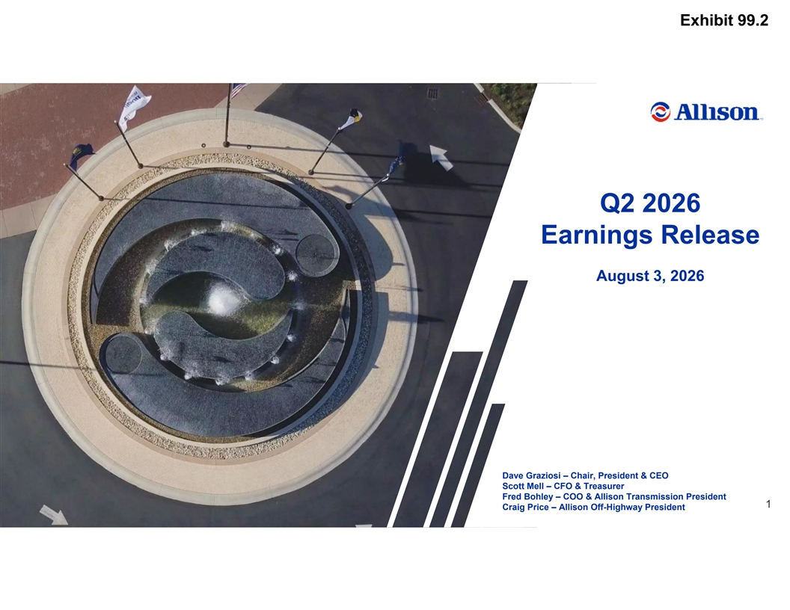
Exhibit 99.2 Q2 2026 Earnings Release August 3, 2026 Dave Graziosi – Chair, President & CEO Scott Mell – CFO & Treasurer Fred Bohley – COO & Allison Transmission President 1 Allison Transmission Confidential: Business Use Only Craig Price – Allison Off-Highway President

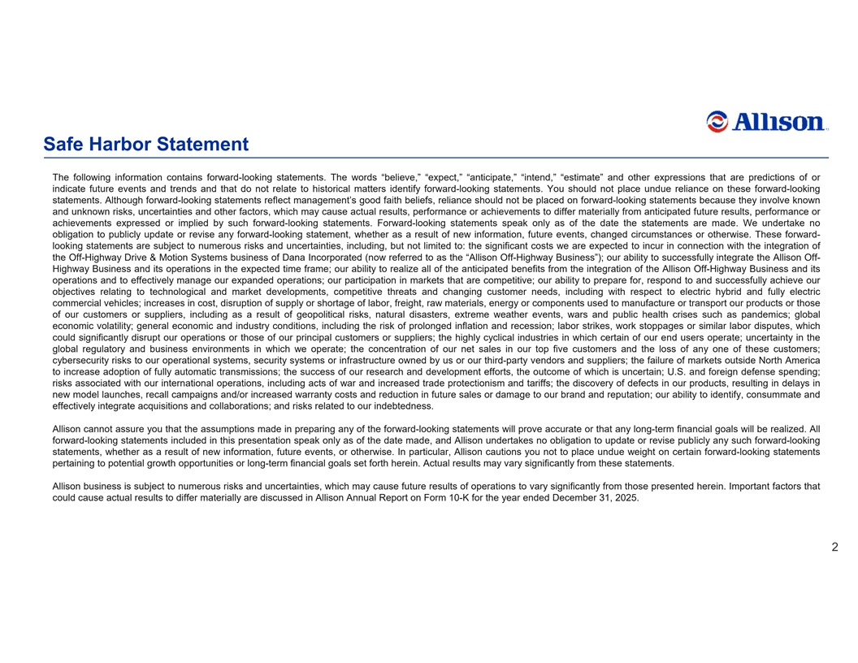
Safe Harbor Statement The following information contains forward-looking statements. The words “believe,” “expect,” “anticipate,” “intend,” “estimate” and other expressions that are predictions of or indicate future events and trends and that do not relate to historical matters identify forward-looking statements. You should not place undue reliance on these forward-looking statements. Although forward-looking statements reflect management’s good faith beliefs, reliance should not be placed on forward-looking statements because they involve known and unknown risks, uncertainties and other factors, which may cause actual results, performance or achievements to differ materially from anticipated future results, performance or achievements expressed or implied by such forward-looking statements. Forward-looking statements speak only as of the date the statements are made. We undertake no obligation to publicly update or revise any forward-looking statement, whether as a result of new information, future events, changed circumstances or otherwise. These forward- looking statements are subject to numerous risks and uncertainties, including, but not limited to: the significant costs we are expected to incur in connection with the integration of the Off-Highway Drive & Motion Systems business of Dana Incorporated (now referred to as the “Allison Off-Highway Business”); our ability to successfully integrate the Allison Off- Highway Business and its operations in the expected time frame; our ability to realize all of the anticipated benefits from the integration of the Allison Off-Highway Business and its operations and to effectively manage our expanded operations; our participation in markets that are competitive; our ability to prepare for, respond to and successfully achieve our objectives relating to technological and market developments, competitive threats and changing customer needs, including with respect to electric hybrid and fully electric commercial vehicles; increases in cost, disruption of supply or shortage of labor, freight, raw materials, energy or components used to manufacture or transport our products or those of our customers or suppliers, including as a result of geopolitical risks, natural disasters, extreme weather events, wars and public health crises such as pandemics; global economic volatility; general economic and industry conditions, including the risk of prolonged inflation and recession; labor strikes, work stoppages or similar labor disputes, which could significantly disrupt our operations or those of our principal customers or suppliers; the highly cyclical industries in which certain of our end users operate; uncertainty in the global regulatory and business environments in which we operate; the concentration of our net sales in our top five customers and the loss of any one of these customers; cybersecurity risks to our operational systems, security systems or infrastructure owned by us or our third-party vendors and suppliers; the failure of markets outside North America to increase adoption of fully automatic transmissions; the success of our research and development efforts, the outcome of which is uncertain; U.S. and foreign defense spending; risks associated with our international operations, including acts of war and increased trade protectionism and tariffs; the discovery of defects in our products, resulting in delays in new model launches, recall campaigns and/or increased warranty costs and reduction in future sales or damage to our brand and reputation; our ability to identify, consummate and effectively integrate acquisitions and collaborations; and risks related to our indebtedness. Allison cannot assure you that the assumptions made in preparing any of the forward-looking statements will prove accurate or that any long-term financial goals will be realized. All forward-looking statements included in this presentation speak only as of the date made, and Allison undertakes no obligation to update or revise publicly any such forward-looking statements, whether as a result of new information, future events, or otherwise. In particular, Allison cautions you not to place undue weight on certain forward-looking statements pertaining to potential growth opportunities or long-term financial goals set forth herein. Actual results may vary significantly from these statements. Allison business is subject to numerous risks and uncertainties, which may cause future results of operations to vary significantly from those presented herein. Important factors that could cause actual results to differ materially are discussed in Allison Annual Report on Form 10-K for the year ended December 31, 2025. 2 Allison Transmission Confidential: Business Use Only

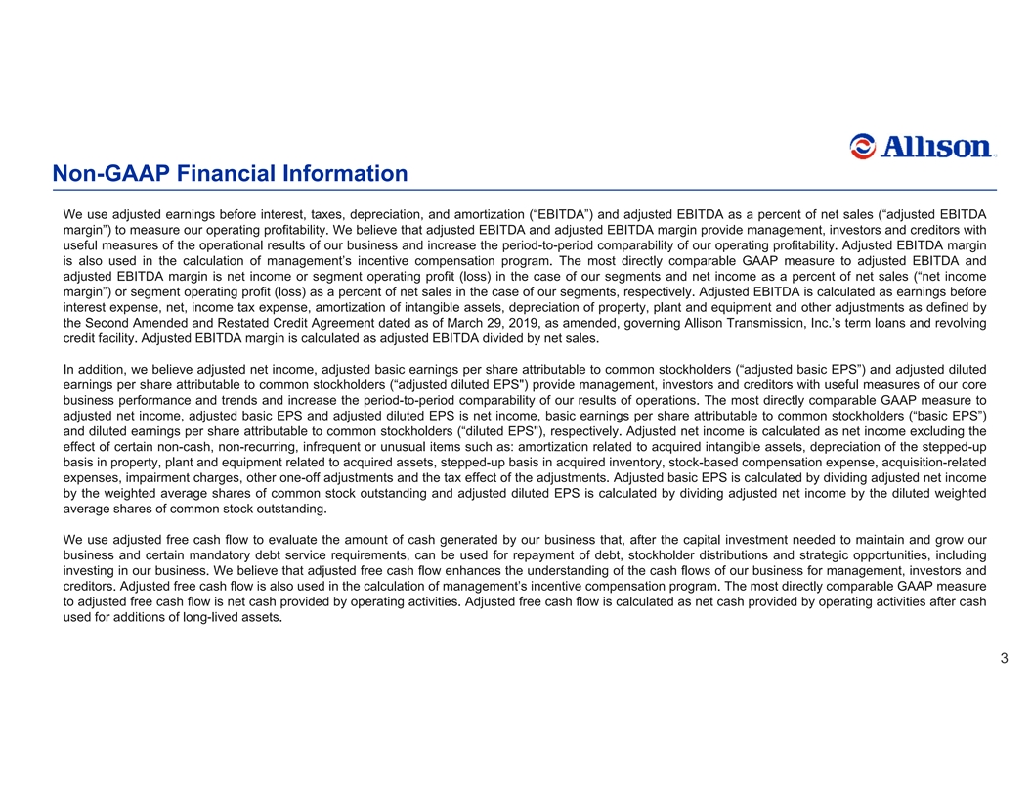
Non-GAAP Financial Information We use adjusted earnings before interest, taxes, depreciation, and amortization (“EBITDA”) and adjusted EBITDA as a percent of net sales (“adjusted EBITDA margin”) to measure our operating profitability. We believe that adjusted EBITDA and adjusted EBITDA margin provide management, investors and creditors with useful measures of the operational results of our business and increase the period-to-period comparability of our operating profitability. Adjusted EBITDA margin is also used in the calculation of management’s incentive compensation program. The most directly comparable GAAP measure to adjusted EBITDA and adjusted EBITDA margin is net income or segment operating profit (loss) in the case of our segments and net income as a percent of net sales (“net income margin”) or segment operating profit (loss) as a percent of net sales in the case of our segments, respectively. Adjusted EBITDA is calculated as earnings before interest expense, net, income tax expense, amortization of intangible assets, depreciation of property, plant and equipment and other adjustments as defined by the Second Amended and Restated Credit Agreement dated as of March 29, 2019, as amended, governing Allison Transmission, Inc.’s term loans and revolving credit facility. Adjusted EBITDA margin is calculated as adjusted EBITDA divided by net sales. In addition, we believe adjusted net income, adjusted basic earnings per share attributable to common stockholders (“adjusted basic EPS”) and adjusted diluted earnings per share attributable to common stockholders (“adjusted diluted EPS ) provide management, investors and creditors with useful measures of our core business performance and trends and increase the period-to-period comparability of our results of operations. The most directly comparable GAAP measure to adjusted net income, adjusted basic EPS and adjusted diluted EPS is net income, basic earnings per share attributable to common stockholders (“basic EPS”) and diluted earnings per share attributable to common stockholders (“diluted EPS ), respectively. Adjusted net income is calculated as net income excluding the effect of certain non-cash, non-recurring, infrequent or unusual items such as: amortization related to acquired intangible assets, depreciation of the stepped-up basis in property, plant and equipment related to acquired assets, stepped-up basis in acquired inventory, stock-based compensation expense, acquisition-related expenses, impairment charges, other one-off adjustments and the tax effect of the adjustments. Adjusted basic EPS is calculated by dividing adjustednet income by the weighted average shares of common stock outstanding and adjusted diluted EPS is calculated by dividing adjusted net income by the diluted weighted average shares of common stock outstanding. We use adjusted free cash flow to evaluate the amount of cash generated by our business that, after the capital investment needed to maintain and grow our business and certain mandatory debt service requirements, can be used for repayment of debt, stockholder distributions and strategic opportunities, including investing in our business. We believe that adjusted free cash flow enhances the understanding of the cash flows of our business for management, investors and creditors. Adjusted free cash flow is also used in the calculation of management’s incentive compensation program. The most directly comparable GAAP measure to adjusted free cash flow is net cash provided by operating activities. Adjusted free cash flow is calculated as net cash provided by operating activities after cash used for additions of long-lived assets. 3 Allison Transmission Confidential: Business Use Only

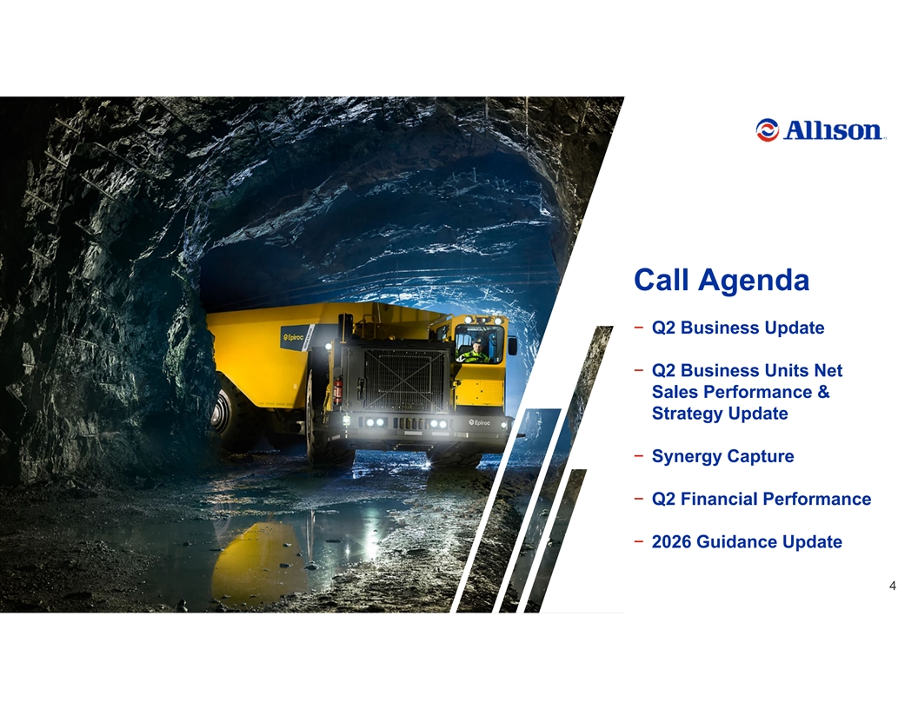
Call Agenda − Q2 Business Update − Q2 Business Units Net Sales Performance & Strategy Update − Synergy Capture − Q2 Financial Performance − 2026 Guidance Update 4 Allison Transmission Confidential: Business Use Only

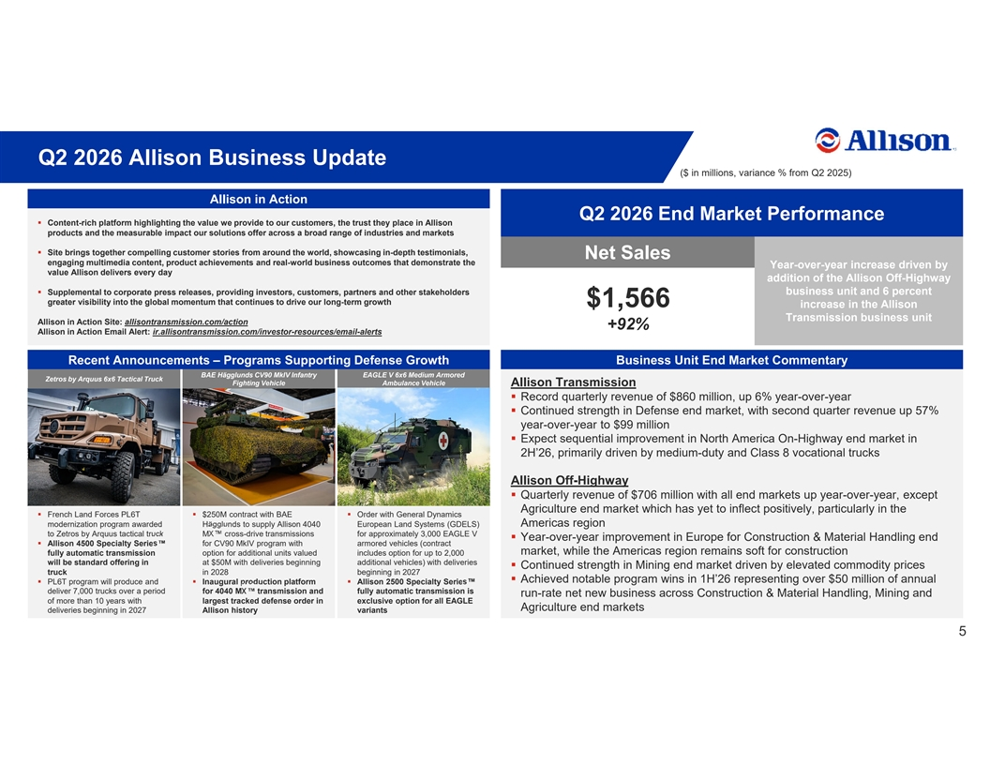
Q2 2026 Allison Business Update ($ in millions, variance % from Q2 2025) Allison in Action Q2 2026 End Market Performance § Content-rich platform highlighting the value we provide to our customers, the trust they place in Allison products and the measurable impact our solutions offer across a broad range of industries and markets § Site brings together compelling customer stories from around the world, showcasing in-depth testimonials, Net Sales engaging multimedia content, product achievements and real-world business outcomes that demonstrate the Year-over-year increase driven by value Allison delivers every day addition of the Allison Off-Highway § Supplemental to corporate press releases, providing investors, customers, partners and other stakeholders business unit and 6 percent greater visibility into the global momentum that continues to drive our long-term growth $1,566 increase in the Allison Transmission business unit Allison in Action Site: allisontransmission.com/action +92% Allison in Action Email Alert: ir.allisontransmission.com/investor-resources/email-alerts Recent Announcements – Programs Supporting Defense Growth Business Unit End Market Commentary BAE Hägglunds CV90 MkIV Infantry EAGLE V 6x6 Medium Armored Zetros by Arquus 6x6 Tactical Truck Fighting Vehicle Ambulance Vehicle Allison Transmission § Record quarterly revenue of $860 million, up 6% year-over-year § Continued strength in Defense end market, with second quarter revenue up 57% year-over-year to $99 million § Expect sequential improvement in North America On-Highway end market in 2H’26, primarily driven by medium-duty and Class 8 vocational trucks Allison Off-Highway § Quarterly revenue of $706 million with all end markets up year-over-year, except Agriculture end market which has yet to inflect positively, particularly in the § French Land Forces PL6T § $250M contract with BAE § Order with General Dynamics modernization program awarded Hägglunds to supply Allison 4040 European Land Systems (GDELS) Americas region to Zetros by Arquus tactical truck MX cross-drive transmissions for approximately 3,000 EAGLE V § Year-over-year improvement in Europe for Construction & Material Handling end § Allison 4500 Specialty Series for CV90 MkIV program with armored vehicles (contract market, while the Americas region remains soft for construction fully automatic transmission option for additional units valued includes option for up to 2,000 will be standard offering in at $50M with deliveries beginning additional vehicles) with deliveries § Continued strength in Mining end market driven by elevated commodity prices truck in 2028 beginning in 2027 § Achieved notable program wins in 1H’26 representing over $50 million of annual § PL6T program will produce and § Inaugural production platform § Allison 2500 Specialty Series deliver 7,000 trucks over a period for 4040 MX transmission and fully automatic transmission is run-rate net new business across Construction & Material Handling, Mining and of more than 10 years with largest tracked defense order in exclusive option for all EAGLE Agriculture end markets deliveries beginning in 2027 Allison history variants 5 Allison Transmission Confidential: Business Use Only

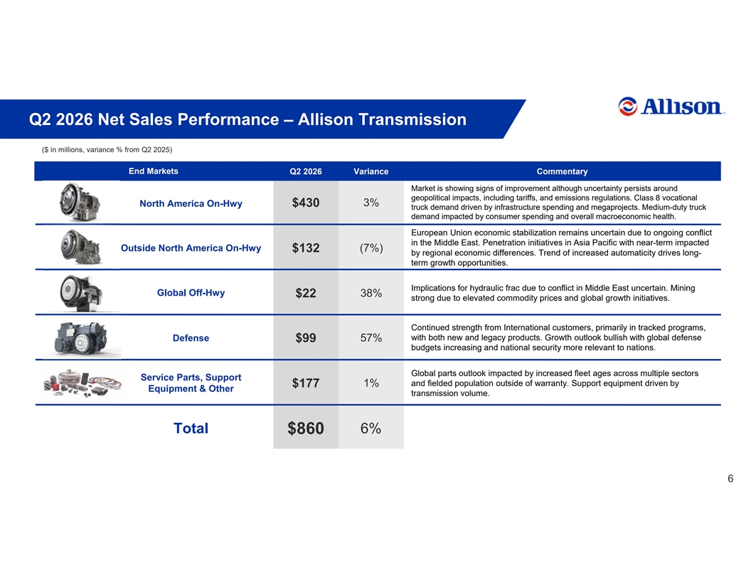
Q2 2026 Net Sales Performance – Allison Transmission ($ in millions, variance % from Q2 2025) End Markets Q2 2026 Variance Commentary Market is showing signs of improvement although uncertainty persists around geopolitical impacts, including tariffs, and emissions regulations. Class 8 vocational North America On-Hwy $430 3% truck demand driven by infrastructure spending and megaprojects. Medium-duty truck demand impacted by consumer spending and overall macroeconomic health. European Union economic stabilization remains uncertain due to ongoing conflict in the Middle East. Penetration initiatives in Asia Pacific with near-term impacted Outside North America On-Hwy $132 (7%) by regional economic differences. Trend of increased automaticity drives long- term growth opportunities. Implications for hydraulic frac due to conflict in Middle East uncertain. Mining Global Off-Hwy 38% $22 strong due to elevated commodity prices and global growth initiatives. Continued strength from International customers, primarily in tracked programs, with both new and legacy products. Growth outlook bullish with global defense Defense $99 57% budgets increasing and national security more relevant to nations. Global parts outlook impacted by increased fleet ages across multiple sectors Service Parts, Support 1% and fielded population outside of warranty. Support equipment driven by $177 Equipment & Other transmission volume. Total 6% $860 6 Allison Transmission Confidential: Business Use Only

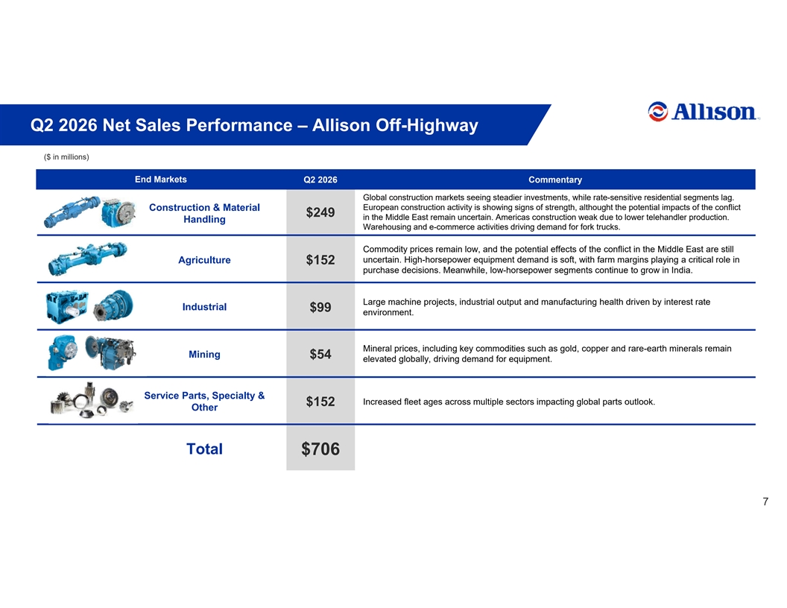
Q2 2026 Net Sales Performance – Allison Off-Highway ($ in millions) End Markets Q2 2026 Commentary Global construction markets seeing steadier investments, while rate-sensitive residential segments lag. Construction & Material European construction activity is showing signs of strength, althought the potential impacts of the conflict $249 in the Middle East remain uncertain. Americas construction weak due to lower telehandler production. Handling Warehousing and e-commerce activities driving demand for fork trucks. Commodity prices remain low, and the potential effects of the conflict in the Middle East are still Agriculture uncertain. High-horsepower equipment demand is soft, with farm margins playing a critical role in $152 purchase decisions. Meanwhile, low-horsepower segments continue to grow in India. Large machine projects, industrial output and manufacturing health driven by interest rate Industrial $99 environment. Mineral prices, including key commodities such as gold, copper and rare-earth minerals remain Mining $54 elevated globally, driving demand for equipment. Service Parts, Specialty & Increased fleet ages across multiple sectors impacting global parts outlook. $152 Other Total $706 7 Allison Transmission Confidential: Business Use Only

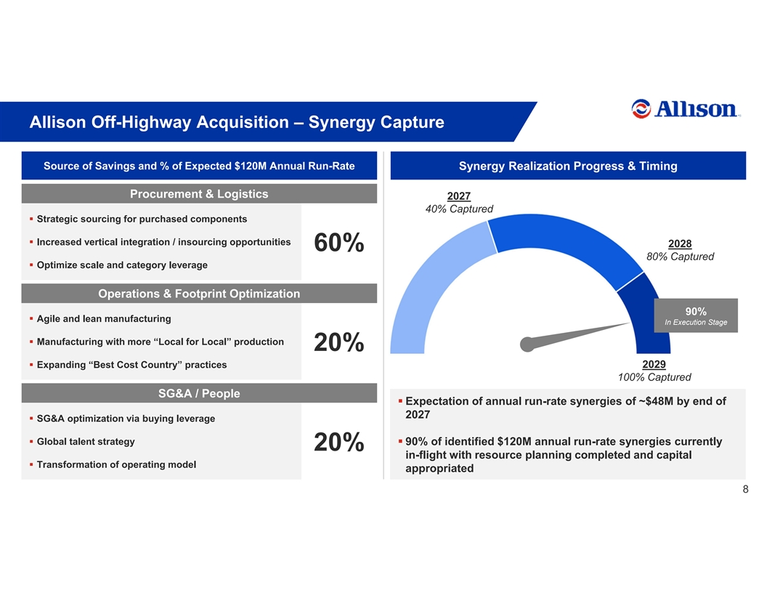
Allison Off-Highway Acquisition – Synergy Capture Source of Savings and % of Expected $120M Annual Run-Rate Synergy Realization Progress & Timing Procurement & Logistics 2027 40% Captured § Strategic sourcing for purchased components § Increased vertical integration / insourcing opportunities 2028 60% 80% Captured § Optimize scale and category leverage Operations & Footprint Optimization 90% § Agile and lean manufacturing In Execution Stage § Manufacturing with more “Local for Local” production 20% § Expanding “Best Cost Country” practices 2029 100% Captured SG&A / People § Expectation of annual run-rate synergies of ~$48M by end of 2027 § SG&A optimization via buying leverage § Global talent strategy § 90% of identified $120M annual run-rate synergies currently 20% in-flight with resource planning completed and capital § Transformation of operating model appropriated 8 Allison Transmission Confidential: Business Use Only

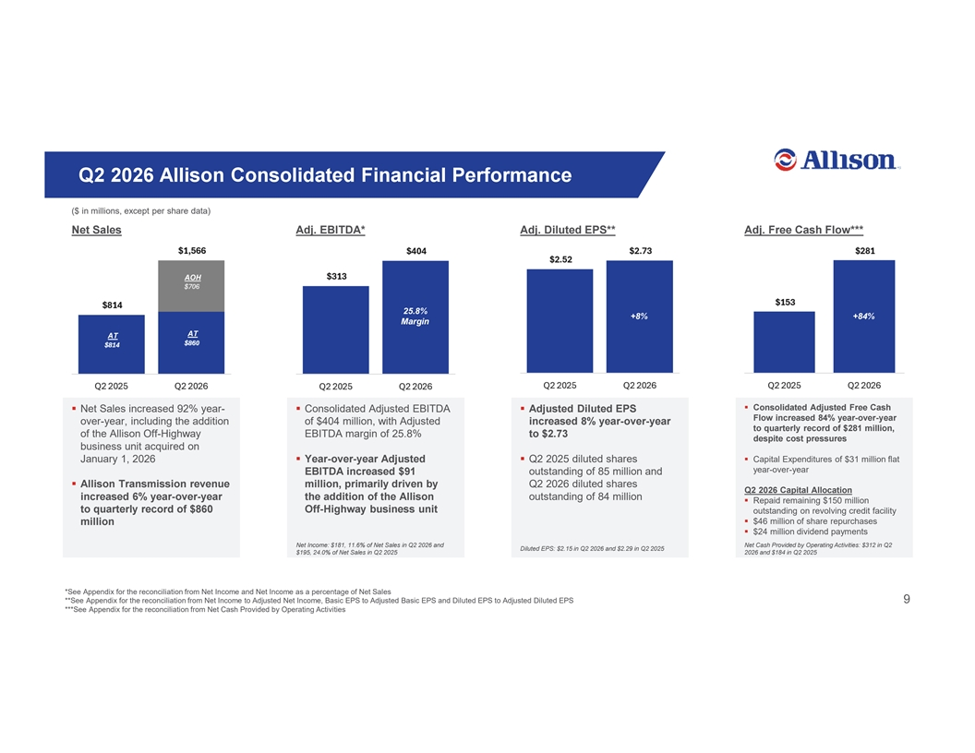
    Q2 2026 Allison Consolidated Financial Performance ($ in millions, except per share data) Net Sales Adj. EBITDA* Adj. Diluted EPS** Adj. Free Cash Flow*** AOH 25.8% +8% +84% Margin AT AT Consolidated Adjusted Free Cash Net Sales increased 92% year- Consolidated Adjusted EBITDA Adjusted Diluted EPS Flow increased 84% year-over-year over-year, including the addition of $404 million, with Adjusted increased 8% year-over-year to quarterly record of $281 million, of the Allison Off-Highway EBITDA margin of 25.8% to $2.73 despite cost pressures business unit acquired on January 1, 2026 Year-over-year Adjusted Q2 2025 diluted shares Capital Expenditures of $31 million flat year-over-year EBITDA increased $91 outstanding of 85 million and Allison Transmission revenue million, primarily driven by Q2 2026 diluted shares Q2 2026 Capital Allocation increased 6% year-over-year the addition of the Allison outstanding of 84 million Repaid remaining $150 million to quarterly record of $860 Off-Highway business unit outstanding on revolving credit facility $46 million of share repurchases million $24 million dividend payments Net Income: $181, 11.6% of Net Sales in Q2 2026 and Net Cash Provided by Operating Activities: $312 in Q2 Diluted EPS: $2.15 in Q2 2026 and $2.29 in Q2 2025 $195, 24.0% of Net Sales in Q2 2025 2026 and $184 in Q2 2025 *See Appendix for the reconciliation from Net Income and Net Income as a percentage of Net Sales **See Appendix for the reconciliation from Net Income to Adjusted Net Income, Basic EPS to Adjusted Basic EPS and Diluted EPS to Adjusted Diluted EPS 9 Allison Transmission Confidential: Business Use Only ***See Appendix for the reconciliation from Net Cash Provided by Operating Activities

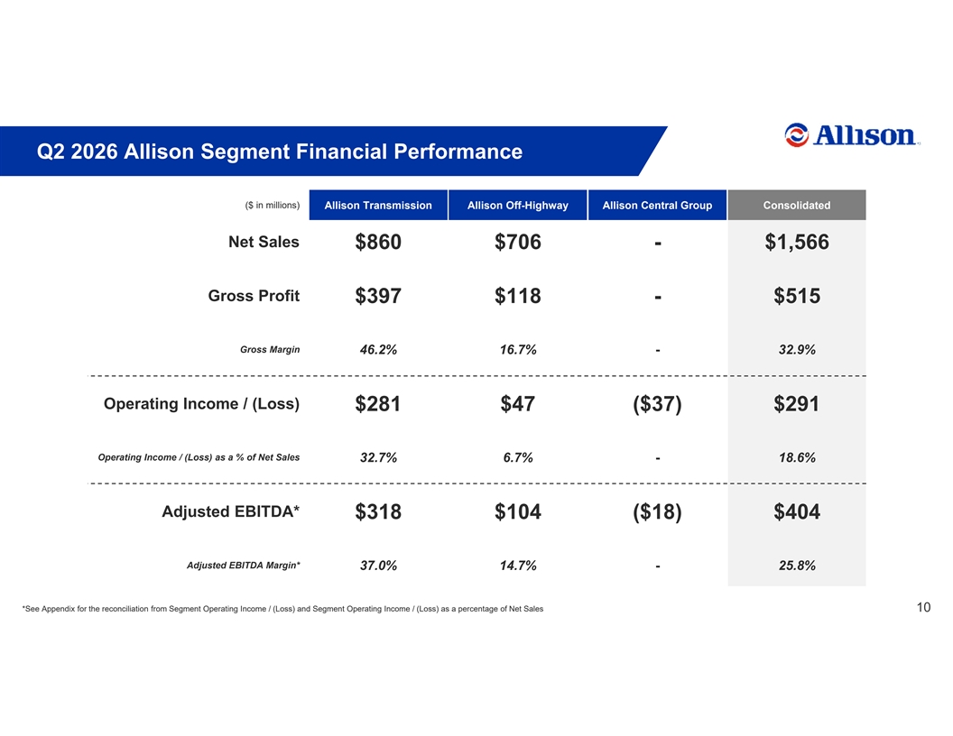
Q2 2026 Allison Segment Financial Performance ($ in millions) Allison Transmission Allison Off-Highway Allison Central Group Consolidated Net Sales $860 $706 - $1,566 Gross Profit $397 $118 - $515 Gross Margin 46.2% 16.7% - 32.9% Operating Income / (Loss) $281 $47 ($37) $291 Operating Income / (Loss) as a % of Net Sales 32.7% 6.7% - 18.6% Adjusted EBITDA* $318 $104 ($18) $404 Adjusted EBITDA Margin* 37.0% 14.7% - 25.8% *See Appendix for the reconciliation from Segment Operating Income / (Loss) and Segment Operating Income / (Loss) as a percentage of Net Sales 10 Allison Transmission Confidential: Business Use Only

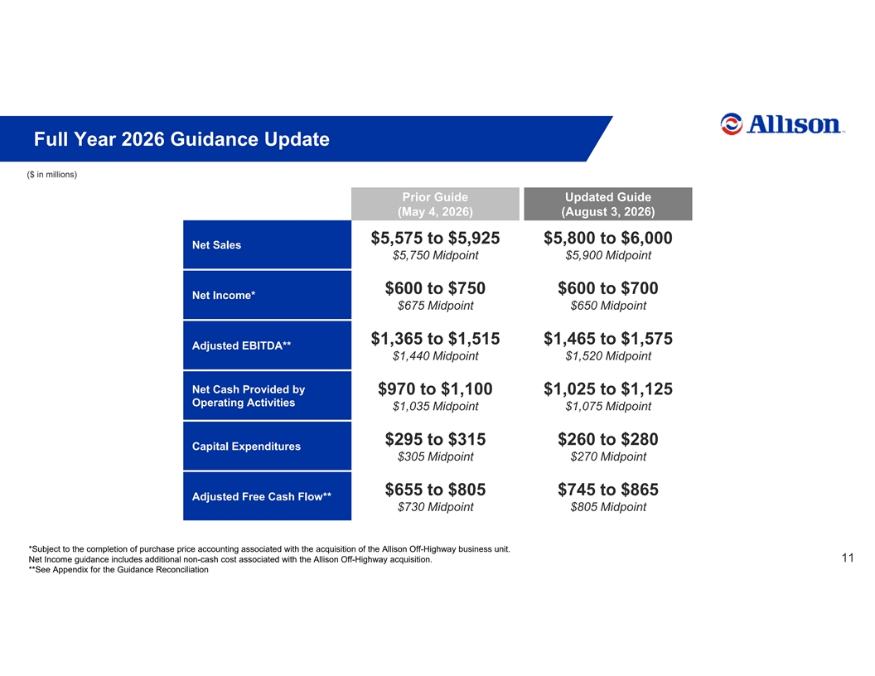
Full Year 2026 Guidance Update ($ in millions) Prior Guide Updated Guide (May 4, 2026) (August 3, 2026) $5,575 to $5,925 $5,800 to $6,000 Net Sales $5,750 Midpoint $5,900 Midpoint $600 to $750 $600 to $700 Net Income* $675 Midpoint $650 Midpoint $1,365 to $1,515 $1,465 to $1,575 Adjusted EBITDA** $1,440 Midpoint $1,520 Midpoint Net Cash Provided by $970 to $1,100 $1,025 to $1,125 Operating Activities $1,035 Midpoint $1,075 Midpoint $295 to $315 $260 to $280 Capital Expenditures $305 Midpoint $270 Midpoint $655 to $805 $745 to $865 Adjusted Free Cash Flow** $730 Midpoint $805 Midpoint *Subject to the completion of purchase price accounting associated with the acquisition of the Allison Off-Highway business unit. Net Income guidance includes additional non-cash cost associated with the Allison Off-Highway acquisition. 11 Allison Transmission Confidential: Business Use Only **See Appendix for the Guidance Reconciliation

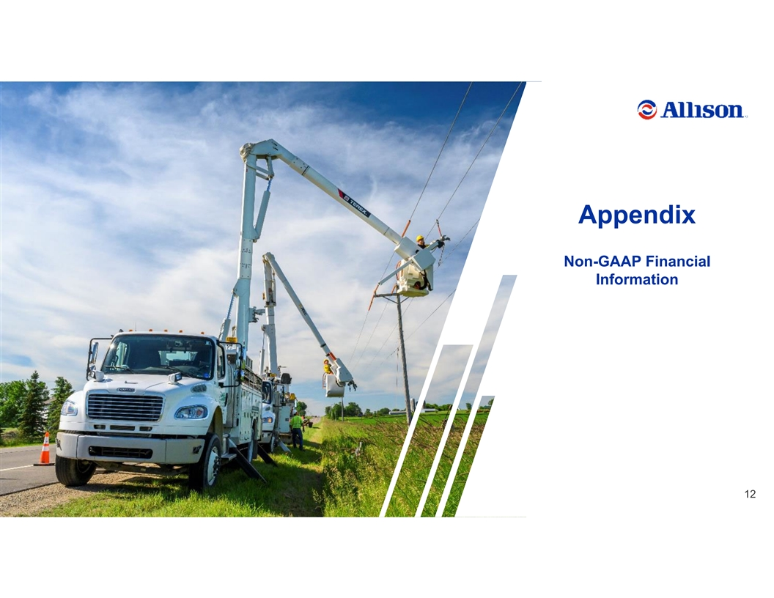
Appendix Non-GAAP Financial Information 12 Allison Transmission Confidential: Business Use Only

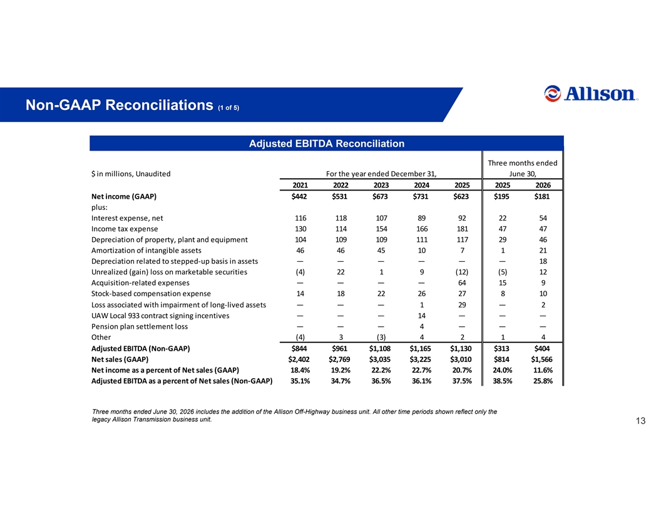
Non-GAAP Reconciliations (1 of 5) Adjusted EBITDA Reconciliation Three months ended $ in millions, Unaudited For the year ended December 31, June 30, 2021 2022 2023 2024 2025 2025 2026 Net income (GAAP) $442 $531 $673 $731 $623 $195 $181 plus: Interest expense, net 116 118 107 89 92 22 54 Income tax expense 130 114 154 166 181 47 47 Depreciation of property, plant and equipment 104 109 109 111 117 29 46 Amortization of intangible assets 46 46 45 10 7 1 21 Depreciation related to stepped-up basis in assets — — — — — — 18 Unrealized (gain) loss on marketable securities (4) 22 1 9 (12) (5) 12 Acquisition-related expenses — — — — 64 15 9 Stock-based compensation expense 14 18 22 26 27 8 10 Loss associated with impairment of long-lived assets — — — 1 29 — 2 UAW Local 933 contract signing incentives — — — 14 — — — Pension plan settlement loss — — — 4 — — — Other (4) 3 (3) 42 14 Adjusted EBITDA (Non-GAAP) $844 $961 $1,108 $1,165 $1,130 $313 $404 Net sales (GAAP) $2,402 $2,769 $3,035 $3,225 $3,010 $814 $1,566 Net income as a percent of Net sales (GAAP) 18.4% 19.2% 22.2% 22.7% 20.7% 24.0% 11.6% Adjusted EBITDA as a percent of Net sales (Non-GAAP) 35.1% 34.7% 36.5% 36.1% 37.5% 38.5% 25.8% Three months ended June 30, 2026 includes the addition of the Allison Off-Highway business unit. All other time periods shown reflect only the legacy Allison Transmission business unit. 13 Allison Transmission Confidential: Business Use Only

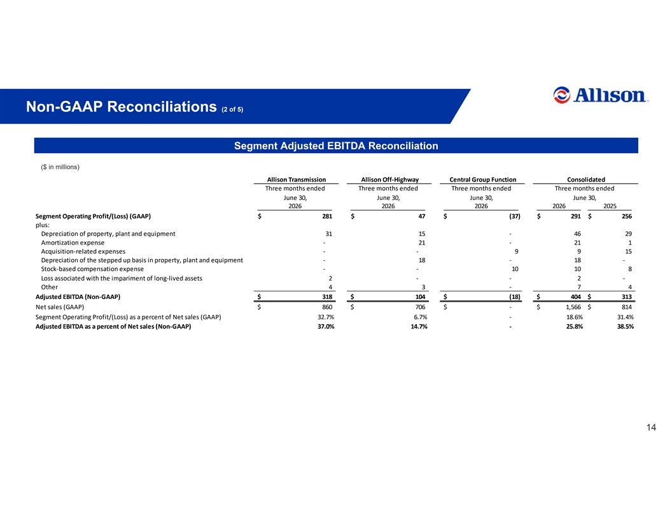
Non-GAAP Reconciliations (2 of 5) Segment Adjusted EBITDA Reconciliation ($ in millions) Allison Transmission Allison Off-Highway Central Group Function Consolidated Three months ended Three months ended Three months ended Three months ended June 30, June 30, June 30, June 30, 2026 2026 2026 2026 2025 Segment Operating Profit/(Loss) (GAAP) $ 281 $ 47 $ (37) $ 291 $ 2 56 plus: Depreciation of property, plant and equipment 31 15 - 4 6 29 Amortization expense - 21 - 2 1 1 Acquisition-related expenses - - 9 9 15 Depreciation of the stepped up basis in property, plant and equipment - 18 - 1 8 - Stock-based compensation expense - - 10 1 0 8 Loss associated with the impariment of long-lived assets 2 - - 2 - Other 4 3 - 7 4 Adjusted EBITDA (Non-GAAP) $ 318 $ 104 $ (18) $ 404 $ 313 Net sales (GAAP) $ 860 $ 706 $ - $ 1,566 $ 814 Segment Operating Profit/(Loss) as a percent of Net sales (GAAP) 32.7% 6.7% - 18.6% 31.4% Adjusted EBITDA as a percent of Net sales (Non-GAAP) 37.0% 14.7% - 25.8% 38.5% 14 Allison Transmission Confidential: Business Use Only

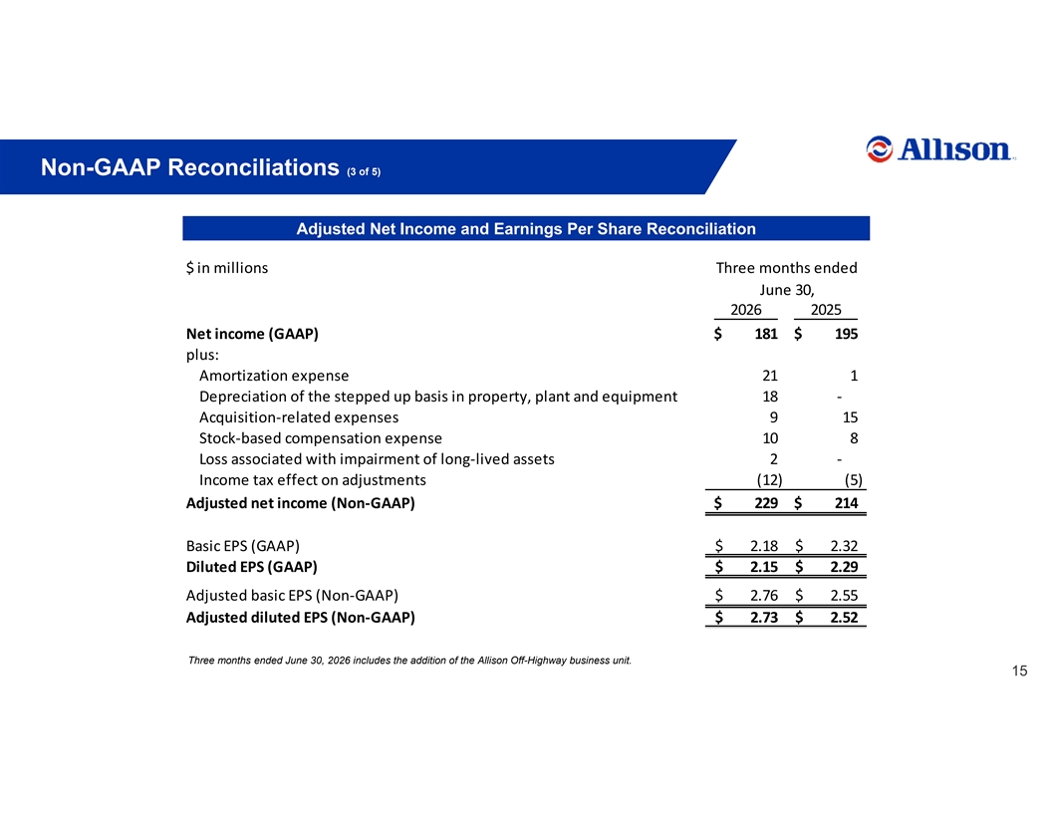
Non-GAAP Reconciliations (3 of 5) Adjusted Net Income and Earnings Per Share Reconciliation $ in millions Three months ended June 30, 2026 2025 Net income (GAAP) $ 181 $ 195 plus: Amortization expense 21 1 Depreciation of the stepped up basis in property, plant and equipment 18 - Acquisition-related expenses 9 15 Stock-based compensation expense 10 8 Loss associated with impairment of long-lived assets 2 - Income tax effect on adjustments (12) (5) Adjusted net income (Non-GAAP) $ 229 $ 214 Basic EPS (GAAP) $ 2.18 $ 2.32 Diluted EPS (GAAP) $ 2.15 $ 2.29 Adjusted basic EPS (Non-GAAP) $ 2.76 $ 2.55 Adjusted diluted EPS (Non-GAAP) $ 2.73 $ 2.52 Three months ended June 30, 2026 includes the addition of the Allison Off-Highway business unit. 15 Allison Transmission Confidential: Business Use Only

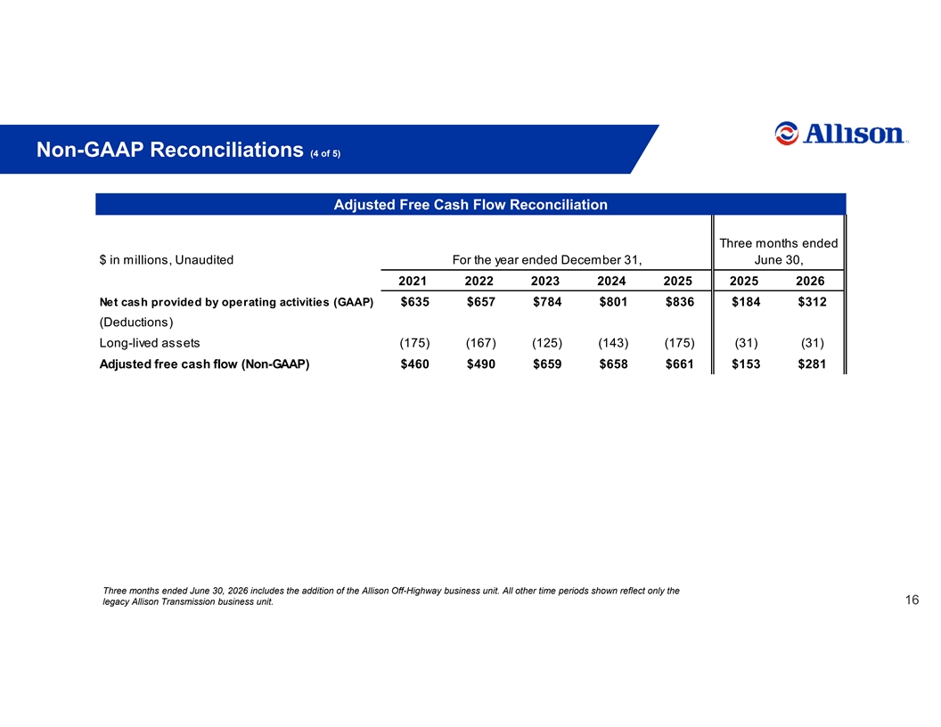
Non-GAAP Reconciliations (4 of 5) Adjusted Free Cash Flow Reconciliation Three months ended $ in millions, Unaudited For the year ended December 31, June 30, 2021 2022 2023 2024 2025 2025 2026 Net cash provided by operating activities (GAAP) $635 $657 $784 $801 $836 $184 $312 (Deductions) Long-lived assets (175) (167) (125) (143) (175) (31) (31) Adjusted free cash flow (Non-GAAP) $460 $490 $659 $658 $661 $153 $281 Three months ended June 30, 2026 includes the addition of the Allison Off-Highway business unit. All other time periods shown reflect only the legacy Allison Transmission business unit. 16 Allison Transmission Confidential: Business Use Only

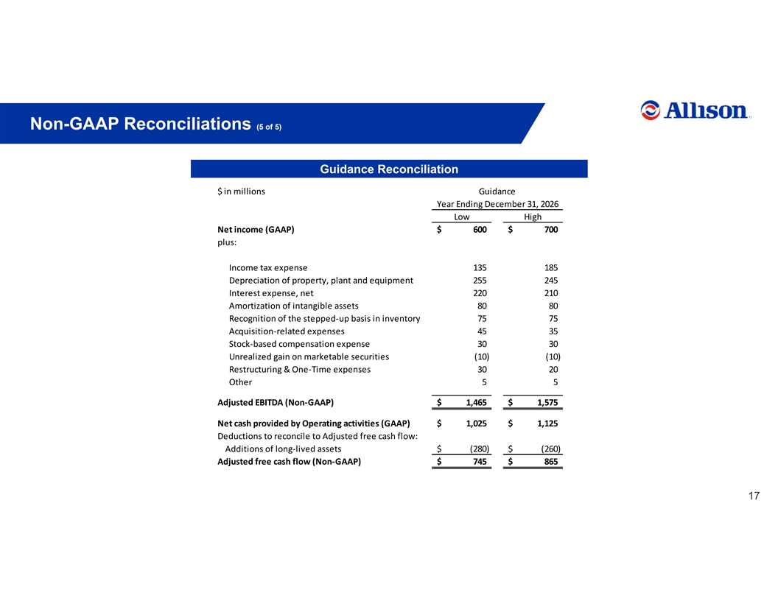
Non-GAAP Reconciliations (5 of 5) Guidance Reconciliation $ in millions Guidance Year Ending December 31, 2026 Low High Net income (GAAP) $ 600 $ 700 plus: Income tax expense 135 185 Depreciation of property, plant and equipment 255 245 Interest expense, net 220 210 Amortization of intangible assets 80 80 Recognition of the stepped-up basis in inventory 75 75 Acquisition-related expenses 45 35 Stock-based compensation expense 30 30 Unrealized gain on marketable securities (10) (10) Restructuring & One-Time expenses 30 20 Other 5 5 Adjusted EBITDA (Non-GAAP) $ 1,465 $ 1,575 Net cash provided by Operating activities (GAAP) $ 1,025 $ 1,125 Deductions to reconcile to Adjusted free cash flow: Additions of long-lived assets $ (280) $ (260) Adjusted free cash flow (Non-GAAP) $ 745 $ 865 17 Allison Transmission Confidential: Business Use Only

